|  |
| --- |
|  |
| 新概念 3 册 |
| Lesson27 Nothing to sell and nothing to buy |

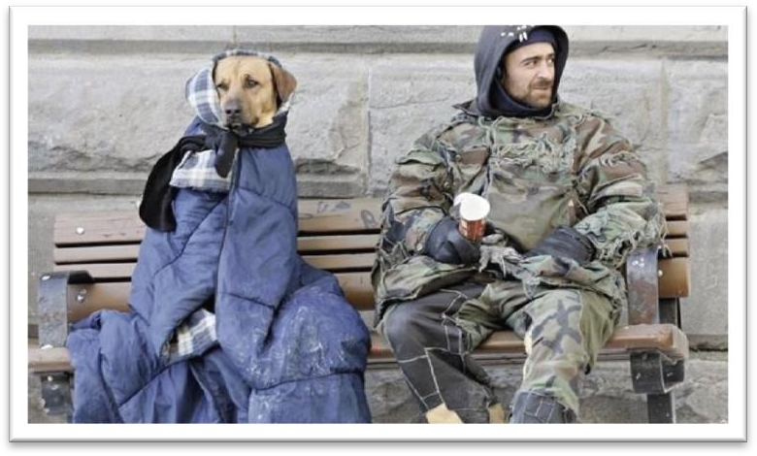

Book

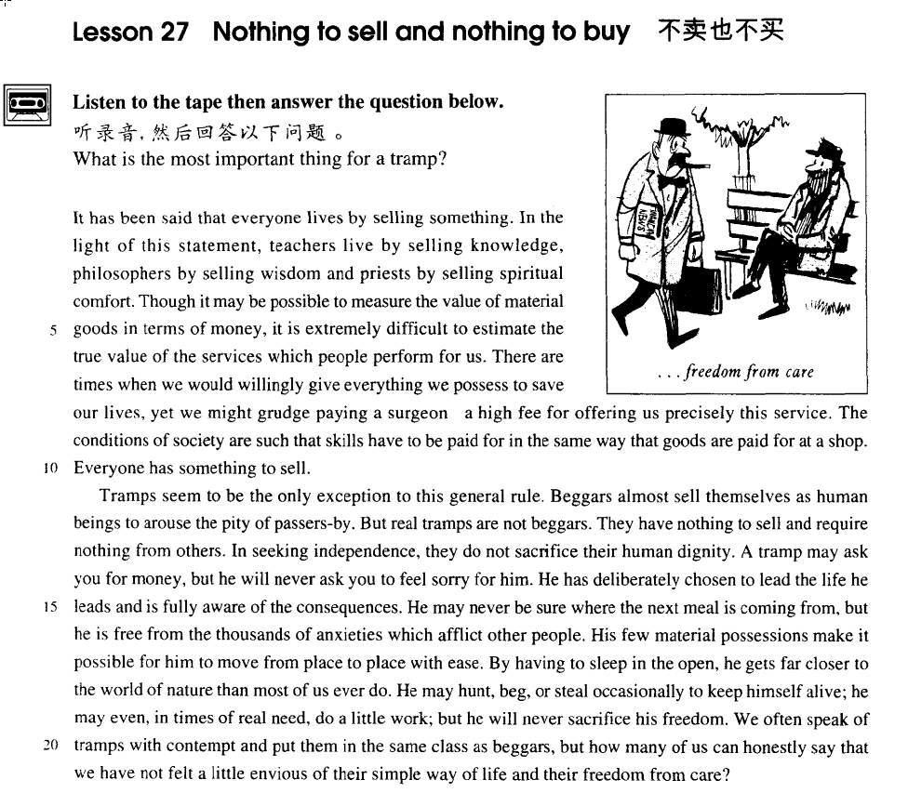

课文

It has been said that everyone lives by selling something.

据说每个人都靠出售某种东西来维持生活。

In the light of this statement, teachers live by selling knowledge, philosophers by selling wisdom and priests by selling spiritual comfort.

根据这种说法，教师靠卖知识为生，哲学家靠卖智慧为生，牧师靠卖精神安慰为生。

Though it may be possible to measure the value of material goods in terms of money, it is extremely difficult to estimate the true value of the services which people perform for us.

虽然物质产品的价值可以用金钱来衡量，但要估算别人为我们为所提供的服务的价值却是极其困难的。

There are times when we would willingly give everything we possess to save our lives, yet we might grudge paying a surgeon a high fee for offering us precisely this service.

有时，我们为了挽救生命，愿意付出我们所占有的一切，但就在外科大夫给我们提供了这种服务后，我们却可能为所支付的昂贵的费用而抱怨。

The conditions of society are such that skills have to be paid for in the same way that goods are paid for at a shop.

社会上的情况就是如此，技术是必须付钱去买的，就像在商店里要花钱买商品一样。

Everyone has something to sell.

人人都有东西可以出售。

Tramps seem to be the only exception to this general rule.

在这条普遍的规律前面，好像只有流浪汉是个例外，

Beggars almost sell themselves as human beings to arouse the pity of passers-by.

乞丐出售的几乎是他本人，以引起过路人的怜悯。

But real tramps are not beggars.

但真正的流浪并不是乞丐。

They have nothing to sell and require nothing from others.

他们既不出售任何东西，也不需要从别人那儿得到任何东西，

In seeking independence, they do not sacrifice their human dignity.

在追求独立自由的同时，他们并不牺牲为人的尊严。

A tramp may ask you for money, but he will never ask you to feel sorry for him.

游浪汉可能会向你讨钱，但他从来不要你可怜他。

He has deliberately chosen to lead the life he leads and is fully aware of the consequences.

他是故意在选择过那种生活的，并完全清楚以这种方式生活的后果。

He may never be sure where the next meal is coming from, but he is free from the thousands of anxieties which afflict other people.

他可能从不知道下顿饭有无着落，但他不像有人那样被千万桩愁事所折磨。

His few material possessions make it possible for him to move from place to place with ease.

他几乎没有什么财产，这使他能够轻松自如地在各地奔波。

By having to sleep in the open, he gets far closer to the world of nature than most of us ever do.

由于被迫在露天睡觉，他比我们中许多人都离大自然近得多。

He may hunt, beg, or steal occasionally to keep himself alive; he may even, in times of real need, do a little work; but he will never sacrifice his freedom.

为了生存，他可能会去打猎、乞讨，偶尔偷上一两回；确实需要的时候，他甚至可能干一点儿活，但他决不会牺牲自由。

We often speak of tramps with contempt and put them in the same class as beggars, but how many of us can honestly say that we have not felt a little envious of their simple way of life and their freedom from care?

说起流浪汉，我们常常带有轻蔑并把他们与乞丐归为一类，但是我们中有多少人能够坦率地说我们对流浪汉的简朴生活与无忧无虑的境况不感到有些羡慕呢?

词汇讲解

* **philosopher [fə'lɒsəfə(r)]** n. 哲学家

**词根：**“phil” = love 爱

**philosopher** ***n.*** 哲学家；哲人

**philosophy** ***n.*** 哲学；哲理；人生观

**philology** ***n.*** 文献学；语言学

**philologist** ***n.*** 文献学者；语言学者

**词根：**“soph” = wisdom 智慧

**sophomore** ***n.*** 大学二年级生；（美）有二年经验的人

**sophisticated** ***adj.*** 复杂的；精致的；久经世故的；富有经验的

* **spiritual** ['spɪrɪtʃuəl] adj. 精神的

**spiritual** 精神的

* spiritual civilization 精神文明

**material** 物质的

* material civilization 物质文明

**mental** 脑力的

* mental labor 脑力劳动

**manual / physical** 体力的

* manual / physical labor 体力劳动

**intellectual** 智力的

* intellectual development 智力开发

**intelligent** 智商高的

* intelligent beings 智慧生物
* **grudge** [ɡrʌdʒ]v. 吝惜，不愿意给

**grudge + n. / doing**

* He **grudges** paying taxes.
* He **grudges** the money he pays in tax.

**grudging** ***adj.*** 勉强的；吝啬的

**reluctant** ***adj.*** 不情愿的；勉强的；顽抗的

**unwilling** ***adj.*** 不愿意的；不情愿的；勉强的

**grudge**（名词）恶意，怨恨

**have / bear / hold a grudge** 怀恨在心

* **托福听力真题：**

A．She has a bad memory.

B．She's quick to forgive people.

C．Her feelings are easily hurt.

D．She doesn't get angry very often.

* W: I wish I hadn’t hurt Mary’s feelings like that. You know I’ve never meant to.
* M: The great thing about Mary is that she doesn’t **hold a grudge**. By tomorrow she’ll have forgotten all about it.
* Q: What does the man say about Mary?
* Answer: (B) She's quick to forgive people.
* **dignity ['dɪɡnətɪ]** n. 尊严

**beneath one’s dignity** 有失尊严

* Arguing with you is **beneath my dignity**.

**self-respect** 自尊

**self-esteem** 自尊

**indignity** ***n.*** 侮辱；轻蔑；有伤尊严；无礼举动

**shame / disgrace / humiliation** (近义词) 羞辱、侮辱

**indignation *n.*** 愤慨；愤怒；义愤

**anger / rage / fury** (近义词) 气愤

* **deliberately** [dɪ'lɪbərətli] adv. 故意地

**deliberately** ***adv.*** 故意地；谨慎地；慎重地

**intentionally** ***adv.*** 故意地，有意地

**on** **purpose** ***na.*** 故意；意欲

accidentally ***adv.*** 意外地；偶然地

by accident ***na.*** 偶然 (opp. on purpose)

by chance ***na.*** 偶然

* **afflict** [ə'flɪkt] v. 使苦恼，折磨

**afflict sb.** 使某人苦恼/折磨

**be afflicted with/by …**

* He was **afflicted with/by** his injured leg

**inflict** ***vt.*** 造成；使遭受（损伤、痛苦等）；给予（打击等）

**inflict sth. on sb.** 把令人痛苦的事强加倒某人身上

* Please don’t **inflict** your love **on** me.

**conflict** ***n.*** 冲突，矛盾；斗争；争执

**in conflict** 有矛盾；不一致；发生冲突

* The employers and workers are **still in conflict**.

**sb. suffer (from) sth.** 某人因某事而痛苦

**sth. distress sb.** 令某人痛苦（精神上的）

**sth. torture / torment / rack sb.** 令某人非常痛苦

* God Almighty, where are you when the world **is racked** by war?
* **ease** [i:z] n. 容易；舒适

**with ease** = **easily** 轻松地

* He passed the exam **with ease**.

**at ease** = **in comfort** = **comfortably** 舒服地

* He sat there **at ease**.
* **contempt** [kən'tempt] n. 蔑视

**hold … in contempt** 鄙视某人

**contemptuous** ***adj.*** 轻蔑的；侮辱的

**despise** ***vt.*** 轻视，鄙视

**scorn** ***vt.*** 轻蔑；藐视；不屑做 ***vi.*** 表示轻蔑；表示鄙视

**look down on / upon …** 鄙视/轻视

* **envious** ['enviəs] adj. 羡慕的

**be envious of …** 对…很羡慕

**envy** ***vt.*** 嫉妒，妒忌；羡慕 ***vi.*** 感到妒忌；显示出妒忌 ***n.*** 嫉妒，妒忌；羡慕

* You lucky dog, I **envy** you.
* You are my **envy**.
* His talent is the **envy** of his colleagues.

**jealous** ***adj.*** 妒忌的；猜疑的；唯恐失去的；戒备的

**be jealous of …** 对…嫉妒

**jealousy *n.*** 嫉妒；猜忌；戒备

课文讲解

# （第一段）

# It has been said that everyone lives by selling something.

知识点（1）

**“据说”**固定句型：**用完成时，强调对现在有影响**

* It has been said that everyone lives by selling something.

表达**“据说”**:

**It is said that …**

**They say that …**

**People say that …**

其他相似表达：

**It is reported that …** 据报道…

**It is believed that …** 拒信…

**It is estimated that …** 据估计…

**It must be admitted that …** 必须要承认的是…

**It must be pointed out that …** 必须要指出…

**It must be stressed that …** 必须要强调的是…

**It can be foreseen that …** 可以被预见到的是…

知识点（2）

**live by doing** 靠某种职业为生

* He **lives by** writing.
* He **lives by** sewing.
* The nomads who made these markings **lived by** hunting and fishing during the last Ice Age which began about 35,000 B.C. and ended about 10,000 B.C.

**live on sth.** 靠某种食物或生活来源为生（指人）

* He **lives on** meat and milk.
* He **lives on** salary.
* He **lives on** his parents. 啃老

**feed on sth.** 动物以……为主食

* Cows **feed on** hay.

**prey on sth.** 肉食性动物以别的动物为食

* Owls **prey on** mice.

# In the light of this statement, teachers live by selling knowledge, philosophers by selling wisdom and priests by selling spiritual comfort.

**语法分析：**

In the light of this statement（介词短语做状语）, teachers live by selling knowledge, philosophers by selling wisdom and priests by selling spiritual comfort. （三个并列句）

知识点（1）

**in (the) light of sth.** 根据……；鉴于……

* **四级阅读真题：**
* Reading is thought to be a kind of conversation between the reader and the text. The reader puts questions, as it were, to the text and gets answers. **In the light of** these he puts further questions, and so on.
* **考研真题：英译汉**
* He explores such problem consciously, articulately, and frankly, first by asking factual questions, then by asking moral questions, finally by suggesting action which seems appropriate **in the light of** the factual and moral information which he has obtained.
* **六级真题：单选**
* I am afraid that you have to alter your ___C___ views in light of the tragic news that has just arrived.

(A) indifferent (B) distressing (C) optimistic (D) pessimistic

表达**“根据……”**相关短语：

**in (the) light of sth.** 根据……；鉴于……

**according to sth.**

**in accordance with sth.**

**considering sth.**

**taking into account sth.**

知识点（2）

**语法：并列句中重复的谓语动词可省略**，如果后面是介词一般习惯留下介词

* In the light of this statement, teachers **live by** selling knowledge, philosophers **(live) by** selling wisdom **and** priests **(live) by** selling spiritual comfort.
* Mary was happy, but / and / while / whereas Jane (**was**) miserable.
* Mary was happy **when** Jane **was** miserable. 从句不能省略

知识点（3）

**课文文法：**parallelism **排比**，把结构相同或类似的词汇、短语和句子并列放在一块，增强语言的气势。

* Some books are to be tasted, others to be swallowed, and some few to be chewed and digested. — Francis Bacon
* Reading makes a full man, conference a ready man, and writing an exact man. ———Francis Bacon
* **考研阅读真题：** 并列句的省略
* It is said that in England **death is** pressing, in Canada **(death is)** inevitable and in California **(death is)** optional. Small wonder. Americans’ life expectancy has nearly doubled over the past century. Failing hips **can be** replaced, clinical depression **(can be)** controlled, cataracts **(can be)** removed in a 30-minutes surgical procedure.

# Though it may be possible to measure the value of material goods in terms of money, it is extremely difficult to estimate the true value of the services which people perform for us.

**语法分析：**

Though（引导让步状语从句） it（形式主语） may be possible *to（真正主语） measure the value of material goods in terms of money（方式状语）*,（**主句） it（形式主语） is extremely difficult *to（真正主语） estimate the true value of the services*** *which（宾语从句） people perform for us*.

知识点（1）

**语法复习：**强调句

* **Possible *as***it may be to measure the value of material goods in terms of money, …
* Although she is beautiful, I still don’t like her.
* **Beautiful *as***she is, I still don’t like her.

知识点（2）

**in terms of ...** 以某种方式；从某个角度

* **In terms of** money we’re rich, but not in terms of happiness.
* **四级真题：单选**
* Which sport has the most expenses___B___ training equipment, players’ personal equipment and uniforms?

(A) in place of (B) **in terms of** (C) by means of (D) by way of

知识点（3）

**perform**: do; carry out 做；执行

# There are times when we would willingly give everything we possess to save our lives, yet we might grudge paying a surgeon a high fee for offering us precisely this service.

**语法分析：**

**There are times（主句）** when（定语从句，修饰times） we would willingly give everything we possess （定语从句，修饰everything）*to save (不定式) our lives*, **yet（连词，引出并列句） we might grudge paying a surgeon a high fee** *for offering us precisely this service（目的状语）*.

知识点（1）

**there are times when ...** = **sometimes** 有时候

* **There are times when** even the tiger sleeps.
* **There are times when** silence has the loudest voice.

**there was a time when …** = **once** 曾经、有一段时期，（按时现在已经不这样了）

* **There was a time** when the owners of shops and businesses in Chicago had to pay large sums of money to gangsters in return for 'protection'.

**there are rare instances when …**= **occasionally** 偶尔的，在个别情况下

* **There are rare instances when** justice almost ceases to be an abstract concept.
* **造句**：在个别情况下，爱国主义(patriotism)不再是一个空洞的口号(an empty slogan)
* **There are rare instances** when patriotism ceases to be an empty slogan.

知识点（2）

**grudge**

* ... we might **grudge** paying a surgeon a high fee for offering us precisely this service.
* ... we might **grudge** the high fee we would pay a surgeon for offering us precisely this service.

知识点（3）

**for** 等价交换

* She gave me $30 **for** my bike.
* She bought my bike **for** $30.

**for nothing** 免费

* Advertisers discovered years ago that all of us love to get something **for nothing**.
* **造句**：有时候我们愿意给为我们服务的侍者小费 (pay tips) 并称赞 (pay compliments) 他们， 但是在母亲为我们提供一样的服务的时候我们却吝惜感谢 (give thanks to …) 之辞。
* There are times when we would willingly pay tips and compliments to the waiters who serve us, yet we might grudge giving thanks to our mothers for offering us precisely this service.

# The conditions of society are such that skills have to be paid for in the same way that goods are paid for at a shop.

**语法分析：**

The conditions of society are **such** （主句）that（such的同位语） skills have to be paid for ***in the same way （方式状语）*** *that （定语从句，修饰way） goods are paid for at a shop*.

知识点（1）

**语法复习：**部分倒装

* **Such are the conditions of society** that skills have to be paid for in the same way that goods are paid for at a shop.
* **Such is human nature** that a great many people are often willing to sacrifice higher pay for the privilege of becoming white-collar workers.

知识点（2）

**语法：**先行词是way，后面的定语从句的形式， 表达“**正如**”

… the same way **in which** … (which为关系代词，指代way)

… the same way **that** … (that为关系**副词，**在句中不当主语，宾语或表语)

… the same way **/（省略）** …

* **造句**：学校里的情况就是这样，优等生 (A students) 受到尊敬 (respect)，正如社会上成功者(achievers) 受人景仰 (esteem) 一样。
* The conditions of schools are such that A students are respected **in the same way that** achievers are esteemed in the society.

**just as** 正像…（引导方式状语从句）

* The conditions of society are such that skills have to be paid for **just as** goods are paid for at a shop.

**alike** 一样的…

* He was adored by rich and poor alike.

**six of one and half a dozen of the other** 半斤八两

* **托福听力真题：**

A．There are six sections of each class.

B．He has to leave since it's almost one o'clock.

C．There are dozens of classes to choose from.

D．It doesn't matter which class the woman takes.

* W: I can't decide whether to take anthropology or geology this term.
* M: It’s **six of one and half a dozen of the other.**
* Q: What does the man mean?
* Answer: (D) It doesn't matter which class the woman takes.

**be equivalent to ...** 相当于…

* The volcanic eruption had an explosive power **equivalent to** 20,000 tons of TNT.

**bear a resemblance to ...** 根…很类似

* Tina **bears a** striking **resemblance to** her mother.
* Your school may have **done away with** （废除了）winners and losers, but life has not. In some schools they have abolished failing grades; they'll give you as many times as you want to get the right answer. **This doesn't bear the slightest resemblance to** anything in real life.

# Everyone has something to sell.

* It has been said that everyone lives by selling something. （主题句）
* Everyone has something to sell. （段落总结句）

**写作总结：**

1. **topic sentence 主题句**
2. **supporting sentences 扩展句（*论证* 和 论据）**
3. **concluding sentence 总结句**

# （第二段）

# Tramps seem to be the only exception to this general rule.

* **课文写法替换：**
* Tramps **seem to be** the only exception to this general rule.
* Tramps **appear to be** the only exception to this general rule.
* **It seems that** tramps are the only exception to this general rule.
* **It appears that** tramps are the only exception to this general rule.

【谚】Every rule has its exception. 每个规则都有例外

**with the exception of ...** 除了…之外

* I like all kinds of films **with the exception of** horror films.

# Beggars almost sell themselves as human beings to arouse the pity of passers-by.

* **课文写法替换：**
* Beggars sell their human dignity **for** the pity of passers-by.
* The moment they reach out their hands they are beggars spiritually.

# But real tramps are not beggars.

# They have nothing to sell and require nothing from others.

# In seeking independence, they do not sacrifice their human dignity.

**语法分析：**

In seeking independence（时间状语）, they do not sacrifice their human dignity.

知识点（1）

**in doing = in the process of doing**  在…的过程中

* **In trying** to solve one problem, I created another.

**on / upon doing** 刚一 … 就

* 课后题：Lesson1
* 6. ___B___ it immediately ran away, (lines 8-9)

(a) Observing her

(b) **On being observed** (强调同时)

(c) Having been observed （强调先后）

(d) On her being observed

* **On being observed,** it immediately ran away.
* **Upon arriving** at the university, I went straight to the dormitory.

知识点（2）

**seek** ***vt.*** 寻求；寻找；探索；搜索 ***vi.*** 寻找；探索；搜索

**seek refuge / asylum** 寻求避难

**seek compensation** 寻求补偿

**seek comfort** 寻求安慰

**seek reelection** 寻求连任

* Virgo woman **seeks** Scorpio man

# A tramp may ask you for money, but he will never ask you to feel sorry for him.

知识点（1）

**feel sorry for …** 同情、怜悯

* Even the bull seemed to **feel sorry for** him, for it looked on sympathetically until the drunk was out of the way before once more turning its attention to the matador.

表达**“同情”**短语：

**feel sorry for …**

**have / feel sympathy for …**

**sympathize with …**

**take pity on …**

# He has deliberately chosen to lead the life he leads and is fully aware of the consequences.

**语法分析：**

He has deliberately chosen to lead the life **he leads（定语从句，修饰life）** and（并列句） is fully aware of the consequences.

知识点（1）

写作：课文中lead的不替换场景，表达强调

* We only **help** those who really need **help**.

知识点（2）

**be aware of …** 意识到、知道

**be conscious of …**

**be unaware of …** 没有意识到、不知道

**be unconscious of …**

**be ignorant of …**（贬义）

# He may never be sure where the next meal is coming from, but he is free from the thousands of anxieties which afflict other people.

**语法分析：**

**He may never be sure**（主句） where（修饰sure） the next meal is coming from, but he is free from the thousands of anxieties *which (定语从句)afflict other people*.

知识点（1）

**be free from ...** 没有…(某个不好的东西)

* He has **been free from** care since he retired.
* The composition **is free from** errors.
* Organic produce **is free from** harmful chemicals.

**free ... from ...** 使…没有…(不想要的东西)

* … but he **frees** himself **from** the thousands of anxieties … （课文写法替换）
* He dedicated his life to **freeing** the world **from** famine and disease.

知识点（2）

afflict ***vt.*** 折磨；使痛苦；使苦恼

* which **distress** other people.
* which **torture / rack / torment** other people.
* which other people **suffer (from)**.

# His few material possessions make it possible for him to move from place to place with ease.

知识点（1）

**make it possible for sb. to do** **= enable sb. to do** 使某人能做某事

* They devise hundreds of competitions which will **enable us to win** huge sums of money. Radio and television have **made it possible for advertisers to capture the** attention of millions of people in this way.

知识点（2）

**from place to place** 各处，四处

**here and there**

**hither and thither**

* The Cutty Sark rolled **from side to side** and it became impossible to steer her.

read sth. **from cover to cover**从头到尾

sell sth. **from door to door** 挨家挨户

vary f**rom person to person** 因人而异

improve **from day to day**日益

**from dawn to dusk** 从早到晚

**from head to foot** 从头到脚

**from top to bottom** 从上到下

**from start to finish** 从头到尾

**from cradle to grave** 从生到死

* A rolling stone gathers no moss. 滚石不生苔

# By having to sleep in the open, he gets far closer to the world of nature than most of us ever do.

**语法分析：**

**By** having to sleep in the open（介词短语做方式状语）, he gets far closer to the world of nature *than most of us ever do（比较状语）*.

知识点（1）

**in the open (air)**: outdoors 在露天、户外

知识点（2）

**语法**：比较状语从句

* He is taller **than** I am.
* He is taller **than** I.
* He is taller **than** me.

# He may hunt, beg, or steal occasionally to keep himself alive; he may even, in times of real need, do a little work; but he will never sacrifice his freedom.

**语法分析：**

He may hunt, beg, or steal occasionally **to keep himself alive(目的状语)**; （分号，充当连词功能）he may even, *in times of real need（插入语）*, do a little work; but he will never sacrifice his freedom.

知识点（2）

表达“偶尔，偶然”：

**occasionally**

**once in a while**

**from time to time**

知识点（2）

**in times of …** 在…的时候

**in times of happiness / grief / rage / crisis / boredom / war / peace …**

* **In times of peace**, when business was bad, Hawkwood and his men would march into a city-state and, after burning down a few farms, would offer to go away if protection money was paid to them.

# We often speak of tramps with contempt and put them in the same class as beggars, but how many of us can honestly say that we have not felt a little envious of their simple way of life and their freedom from care?

**语法分析：**

We often speak of tramps **with contempt** **and** put them in the same class as beggars,） **but**（转折） how many of us can honestly say that we have not felt a little envious of their simple way of life and their freedom from care?（宾语从句）

知识点（1）

We often speak of tramps **with contempt**

= We often speak **contemptuously** of tramps … ***adv.*** 轻蔑地

知识点（2）

**put … in the same class as …** 把…归成…一类

**classify … as …** 把…归成…一类

* … and **classify** them **as** beggars.

知识点（3）

**语法**：rhetorical question 修辞疑问句；不用回答；多用于结尾

* O, wind, **if winter comes, can spring be far behind?** ‘Ode to the West Wind’— P. B. Shelley
* Who among us has not dreamed of that?
* What is the use of our studying grammar if we can't put the grammatical rules into practice?
* Could any spectacle, for instance, be more grimly whimsical than that of gunners using science to shatter men‘s bodies while, close at hand, surgeons use it to restore them?